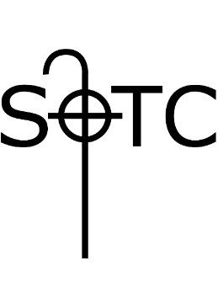

**SOTC Congregational Meeting Agenda**

**November 24, 2024**

Call Meeting to Order

Approval of Agenda

Report from Treasurer on Financial Position of Congregation

Presentation and Discussion of Budget

Vote on proposed budget

*Note that the budget, as presented, has been reviewed and recommended by our Congregational Council for adoption on October 22, 2024.*

Cell Tower Update

Adjournment